Unit 14: Installing and Maintaining Computer Hardware
Task 1:
Installation and Maintenance Activities
Preparation – Getting the proper equipment to install or maintain hardware
Installing different components by taking them out and fitting in new ones if needed
Use certain cleaning tools and cloths to maintain your hardware
Hardware Components, Devices and Software Resources Required For an Upgrade
Reliant on what you are improving, you will need to recognise your factor ensuing with buying or collecting the same merchandise but with complex and better figures towards the determination of the element. Then you should use and if needed purchase a detailed driver software for your element to function, you can buy software either online or at a store.
Example: Installing External Components - Keyboard
If you have a mouse which is not excessively sensitive and is constructed for all-purpose computer usage and there is no likely way to presently update your mouse sensitivity and you wanted a mouse precisely made for gaming. You would proceed to purchase a higher quality mouse which is gaming friendly or made precisely for gaming. After this you will need to hunt online for the driver made for this mouse, which is usually found on the establishment’s website that owns your mouse creation. Then you can endure to install your new mouse to your Computer/Laptop. And if this is a wireless mouse then it should come with a USB Device to input you USB to power your mouse and gain connectivity
Fault Finding Tools and Techniques
Fault Finding
There are a lot of Fault finding tools and techniques, which you usually can find within your computer. What this does is it scans your computer for any errors depending on what the software or in system application it specifies, this then tells you what is wrong with your computer and it may give you solutions towards fixing the problem in your computer.
Techniques
Collect the Evidence
Come with a Method and an open mind, before disturbing or changing anything Stop, Look, Listen and learn, Gather only relevant data, if in doubt about its validity include it and remove later if unrelated. Check the system running if possible, use sources of data, guides, and upkeep records. Use test apparatus to confirm adjustment and surroundings
Analyse the evidence
Distinct the numerous indications and work out the reputation of each one, Check if the proof leads to a beforehand logged error

Locate the fault
Use all possessions available- check apparatus. If possible trace error to component level. Never undertake or remove or check suspect components

Determined and remove the root cause
The fundamental cause of the error must be positioned and removed or else the fault will sooner or later reoccur
Rectify the fault
Any fine-tuning, restoration or replacement should only be carried after recognising and eradicating the cause of the problem
Test the System
Guarantee the engine, gear or system is working properly before being put back into service fine tune if required.
Draft email
The determination of installing new or more RAM, will have satisfied the purpose of giving more progression access to your Workstation, making it stress-free and faster to direct through out your PC without interruption or “bugging out”. My plan shows the method and resources required to install and maintain your Computers speed and effectiveness. By looking at the strategy, it will give you the instructions you need to Connect RAM and know what is required for its fitting.
A thinkable way to uphold and connect hardware is by backing up information, this includes using a flash drive or cd to burn your records onto. Then once you have your records saved onto a trustworthy foundation of storage, you then reload your OS and programmes to fully preserve your PC. This may not be used frequently since some individuals care not to think about something so humble yet a complex method which makes it a good potential alternative to preserve your computer.
An alternative way to preserve your PC is by wiping and dusting it physically. By undertaking this you are making sure that no dust is entering your cooling fan, or producing a pile up against a component (overheating it). This is a humble way yet not continually used since people have faith in the anti-virus software is the answer to a clean PC. But by undertaking this you are making your PC last longer and making it work more resourcefully.

Hardware Description | Installation of RAM, Random-access memory is a form of computer data storage. A random-access memory device allows data items to be read and written in roughly the same amount of time regardless of the order in which data items are accessed
When to install? | You install RAM to make your PC function to process all the tasks needed to run a PC.  You will also install RAM if needed to increase the amount of processes you can access all at once.
Model Number of Installation System | N/A
What hardware tools might you need? E.g. screw driver, wrist wrap, safety goggles etc. | Wrist Wrap
What software tools you may need? E.g. Installation disk | N/A
Safety issues regarding installation | Wrist wrap is needed to reduce risk of electric shock within the PC, even if the PC is turned off and has been disconnected with the power /supply socket.
Backup required (Y/N) | Yes
How do you plan to install it? Write 4 main steps | Step 1 | Turn Off PC And Remove all cables and power sources.
How do you plan to install it? Write 4 main steps | Step 2 | Remove PC Lid and Attack Wrist strap to your wrist and PC (must be metal piece within PC)
How do you plan to install it? Write 4 main steps | Step 3 | Place the RAM into the RAM slots.
How do you plan to install it? Write 4 main steps | Step 4 | Put the lid back onto the PC and put in all power cables etc.
How do you plan to test that the hardware is working? | Once installed the hardware (RAM), then proceed to turn your PC on and either open the bios to check to see if you’re RAM has increased or open your system setting and check the PC specifications within the desktop.
Internet research about the hardware (E.g. links to manual, drivers etc.) | N/A
What are the implications of this installation? ( consider downtime, cost, how many people will it affect) | Costly depending on what size of RAM you purchase. |  | Downtime is not an issue as it takes only a few minutes to set up and install
 | It only affects the user with the PC in a Positive way as it increases their usage within their PC
Test Plan:

Evidence that data was backed up before testing and system settings restored
Step One: Unclutter Your BIOS to check how much RAM you have fitted to your workstation.
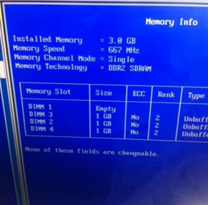
Step Two: Sweeping the cover of your workstation and pinpoint the RAM slots.
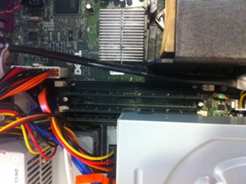
Step Three: Seal as many RAM slots as you can to get the most capable swiftness of your workstation, then put the cover back on your workstation.
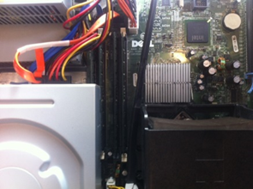
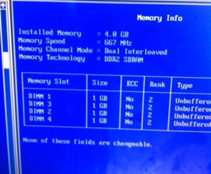
Step Four: Turn your workstation back on and go into the BIOS, then check back to where its shows the data about your RAM, and check to see if you have an enlarged size of RAM in GB. And you have then completed your fitting of the RAM.

